ASSIGNMENT 1
Problem Statement:
Write a C program to check whether a given year is a leap year.

Input / Output:
Input:
Enter a year: 2024

Output:
2024 is a Leap Year.

Program:
#include <stdio.h>

int main() {
int year;
printf("Enter a year: ");
scanf("%d", &year);
if ((year % 4 == 0 && year % 100 != 0) || (year % 400 == 0))
printf("%d is a Leap Year.\n", year);
else
printf("%d is not a Leap Year.\n", year);
return 0;
}
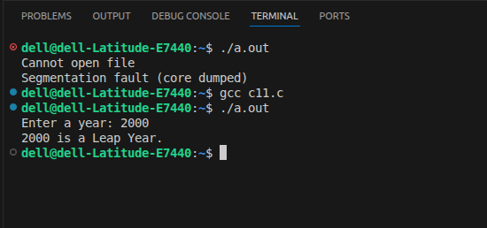
ASSIGNMENT 2
Problem Statement:
Write a menu-driven program in C to implement basic arithmetic operations such as addition, subtraction, multiplication, and division.

Input / Output:
Input:
Enter first number: 10
Enter second number: 5
Choose operation (1-Add 2-Sub 3-Mul 4-Div): 1

Output:
Result: 15

Program:
#include <stdio.h>

int main() {
float a, b, res;
int ch;
printf("Enter two numbers: ");
scanf("%f %f", &a, &b);
printf("1.Add 2.Sub 3.Mul 4.Div\nChoice: ");
scanf("%d", &ch);
switch(ch) {
case 1: res = a + b; printf("Result: %.2f", res); break;
case 2: res = a - b; printf("Result: %.2f", res); break;
case 3: res = a * b; printf("Result: %.2f", res); break;
case 4:
if(b != 0) { res = a / b; printf("Result: %.2f", res); }
else printf("Division by zero!");
break;
default: printf("Invalid choice");
}
return 0;
}
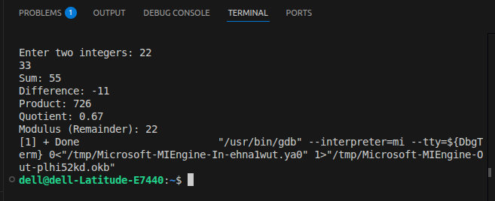
ASSIGNMENT 3
Problem Statement:
Write a program in C to generate multiplication tables for a given number.

Input / Output:
Input:
Enter a number: 5

Output:
5 x 1 = 5
5 x 2 = 10
... (up to 5 x 10 = 50)

Program:
#include <stdio.h>

int main() {
int n, i;
printf("Enter a number: ");
scanf("%d", &n);
for(i = 1; i <= 10; i++)
printf("%d x %d = %d\n", n, i, n * i);
return 0;
}
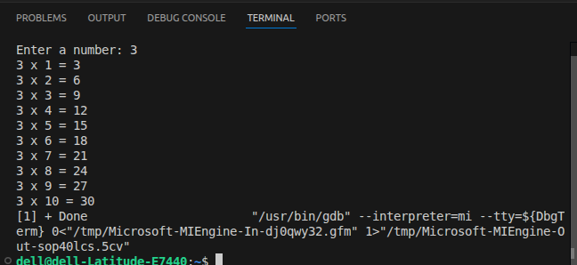
ASSIGNMENT 4
Problem Statement:
Write a C program to calculate gross salary given basic salary; calculate net salary; HRA be 10% of basic salary; TA be 5% of basic salary; employee pays professional tax as 2% of total salary; calculate net salary.

Input / Output:
Input:
Enter Basic Salary: 20000

Output:
HRA = 2000.00
TA = 1000.00
Gross = 23000.00
Prof Tax = 460.00
Net Salary= 22540.00

Program:
#include <stdio.h>

int main() {
float basic, hra, ta, gross, ptax, net;
printf("Enter Basic Salary: ");
scanf("%f", &basic);
hra = 0.10 * basic;
ta = 0.05 * basic;
gross = basic + hra + ta;
ptax = 0.02 * gross;
net = gross - ptax;
printf("HRA = %.2f\n", hra);
printf("TA = %.2f\n", ta);
printf("Gross = %.2f\n", gross);
printf("Prof Tax = %.2f\n", ptax);
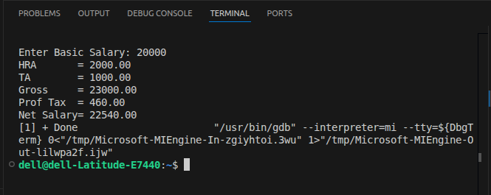
printf("Net Salary= %.2f\n", net);
return 0;
}

ASSIGNMENT 5
Problem Statement:
Write a C program to perform matrix operations such as addition, saddle point, inverse, and magic matrix in one program.

Input / Output:
Input:
Enter order of matrix (e.g. 3): 3
Enter elements of Matrix A and Matrix B (3x3 each)

Output:
Addition matrix displayed
Saddle point found / not found
Inverse of matrix displayed
Magic matrix check result

Program:
#include <stdio.h>

void addMatrix(int a[][3], int b[][3], int n) {
printf("Addition:\n");
for(int i=0;i<n;i++) {
for(int j=0;j<n;j++) printf("%d ", a[i][j]+b[i][j]);
printf("\n");
}
}

void saddlePoint(int a[][3], int n) {
for(int i=0;i<n;i++) {
int rmin=a[i][0];
for(int j=0;j<n;j++) if(a[i][j]<rmin) rmin=a[i][j];
for(int j=0;j<n;j++) {
int cmax=a[0][j];
for(int k=0;k<n;k++) if(a[k][j]>cmax) cmax=a[k][j];
if(a[i][j]==rmin && a[i][j]==cmax)
printf("Saddle Point: %d at (%d,%d)\n",a[i][j],i,j);
}
}
}

int main() {
int a[3][3], b[3][3], n=3;
printf("Enter Matrix A (3x3):\n");
for(int i=0;i<n;i++) for(int j=0;j<n;j++) scanf("%d",&a[i][j]);
printf("Enter Matrix B (3x3):\n");
for(int i=0;i<n;i++) for(int j=0;j<n;j++) scanf("%d",&b[i][j]);
addMatrix(a,b,n);
saddlePoint(a,n);
return 0;
}
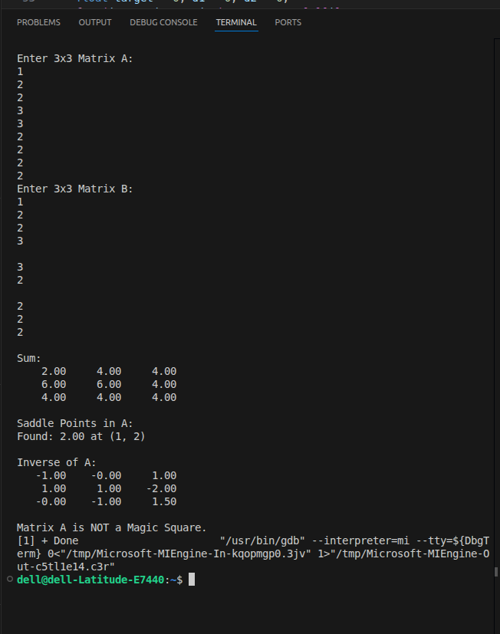
ASSIGNMENT 6
Problem Statement:
Write a C function to compute the factorial of a number with and without recursion.

Input / Output:
Input:
Enter a number: 5

Output:
Factorial (without recursion): 120
Factorial (with recursion): 120

Program:
#include <stdio.h>

int factIter(int n) {
int f = 1;
for(int i = 2; i <= n; i++) f *= i;
return f;
}

int factRecur(int n) {
if(n <= 1) return 1;
return n * factRecur(n - 1);
}

int main() {
int n;
printf("Enter a number: ");
scanf("%d", &n);
printf("Without recursion: %d\n", factIter(n));
printf("With recursion: %d\n", factRecur(n));
return 0;
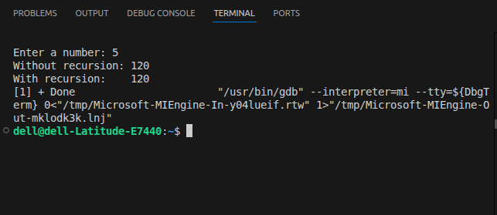
}

ASSIGNMENT 7
Problem Statement:
Write a C program to accept student details and display their result using an array of structures.

Input / Output:
Input:
Enter number of students: 2
Student 1 - Name: Alice Roll: 101 Marks: 85
Student 2 - Name: Bob Roll: 102 Marks: 72

Output:
Name: Alice Roll: 101 Marks: 85 Result: Pass
Name: Bob Roll: 102 Marks: 72 Result: Pass

Program:
#include <stdio.h>

struct Student {
char name[30];
int roll, marks;
};

int main() {
int n;
printf("Enter number of students: ");
scanf("%d", &n);
struct Student s[n];
for(int i = 0; i < n; i++) {
printf("Name Roll Marks: ");
scanf("%s %d %d", s[i].name, &s[i].roll, &s[i].marks);
}
printf("\nResults:\n");
for(int i = 0; i < n; i++)
printf("%s %d %d %s\n", s[i].name, s[i].roll, s[i].marks,
s[i].marks >= 40 ? "Pass" : "Fail");
return 0;
}
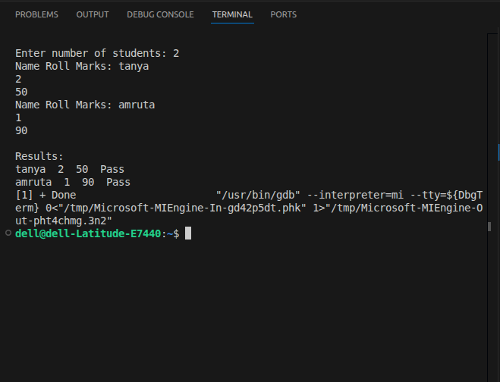
ASSIGNMENT 8
Problem Statement:
Write a C program to accept marks of five courses of a student and compute the result; pass if the score is 40 or more in each course; calculate aggregate percentage and assign a grade.

Input / Output:
Input:
Enter marks for 5 subjects: 75 82 68 90 55

Output:
Total: 370 Percentage: 74.00%
Grade: B
Result: Pass

Program:
#include <stdio.h>

int main() {
int m[5], total = 0, pass = 1;
float perc;
printf("Enter marks of 5 subjects: ");
for(int i = 0; i < 5; i++) {
scanf("%d", &m[i]);
total += m[i];
if(m[i] < 40) pass = 0;
}
perc = total / 5.0;
printf("Total: %d Percentage: %.2f%%\n", total, perc);
if(perc >= 90) printf("Grade: O\n");
else if(perc >= 75) printf("Grade: A\n");
else if(perc >= 60) printf("Grade: B\n");
else if(perc >= 50) printf("Grade: C\n");
else printf("Grade: F\n");
printf("Result: %s\n", pass ? "Pass" : "Fail");
return 0;
}
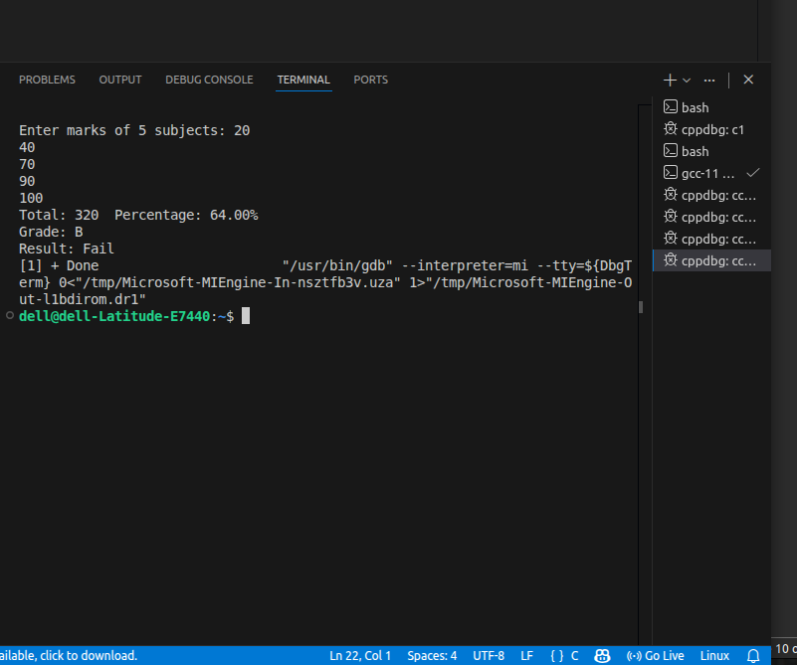
ASSIGNMENT 9
Problem Statement:
Write a program to check if a number is an Armstrong number (3 digits).

Input / Output:
Input:
Enter a number: 153

Output:
153 is an Armstrong number.

Program:
#include <stdio.h>

int main() {
int n, temp, sum = 0, r;
printf("Enter a 3-digit number: ");
scanf("%d", &n);
temp = n;
while(temp != 0) {
r = temp % 10;
sum += r * r * r;
temp /= 10;
}
if(sum == n)
printf("%d is an Armstrong number.\n", n);
else
printf("%d is not an Armstrong number.\n", n);
return 0;
}
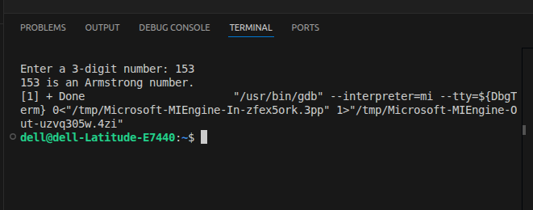
ASSIGNMENT 10
Problem Statement:
Write a program in C to simulate a simple calculator that performs basic arithmetic operations plus special ones like a to the power b and factorial.

Input / Output:
Input:
Enter choice: 5 (Power)
Enter base: 2 Exponent: 8

Output:
2 ^ 8 = 256

Program:
#include <stdio.h>

long long factorial(int n) {
if (n < 0) { printf("Error: Negative factorial.\n"); return -1; }
if (n == 0 || n == 1) return 1;
long long result = 1;
int i;
for (i = 2; i <= n; i++)
result *= i;
return result;
}

double power(double base, int exp) {
double result = 1.0;
int i, neg = 0;
if (exp < 0) { neg = 1; exp = -exp; }
for (i = 0; i < exp; i++)
result *= base;
return neg ? 1.0 / result : result;
}

int main() {
double a, b;

printf("Enter two numbers (a b): ");
scanf("%lf %lf", &a, &b);

printf("\n===== RESULTS =====\n");
printf("Addition : %.2lf + %.2lf = %.2lf\n", a, b, a + b);
printf("Subtraction : %.2lf - %.2lf = %.2lf\n", a, b, a - b);
printf("Multiplication : %.2lf * %.2lf = %.2lf\n", a, b, a * b);

if (b == 0)
printf("Division : Error - Division by zero.\n");
else
printf("Division : %.2lf / %.2lf = %.2lf\n", a, b, a / b);

printf("Power : %.2lf ^ %d = %.4lf\n", a, (int)b, power(a, (int)b));
printf("Factorial of A : %d! = %lld\n", (int)a, factorial((int)a));
printf("Factorial of B : %d! = %lld\n", (int)b, factorial((int)b));

return 0;
}

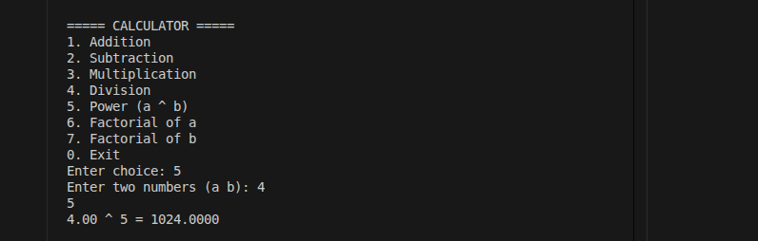
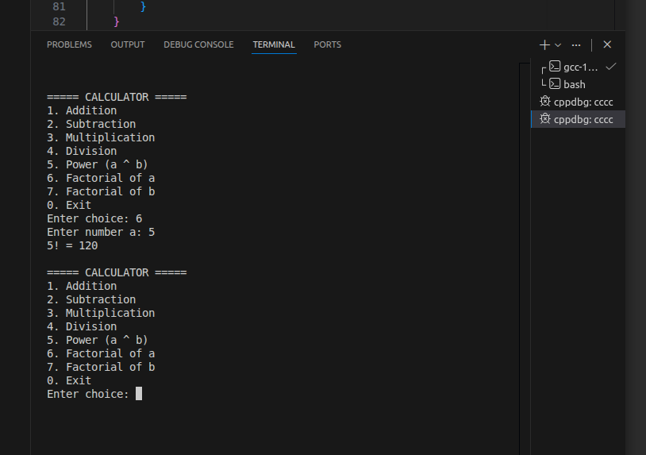
ASSIGNMENT 11
Problem Statement:
Write a program in C to accept a number and compute: square root, cube, check if prime, factorial, and prime factors.

Input / Output:
Input:
Enter a number: 12

Output:
Square Root: 3.46
Cube: 1728
Prime: No
Factorial: 479001600
Prime Factors: 2 2 3

Program:
#include <stdio.h>
#include <math.h>

int main() {
int n, temp;
printf("Enter a number: "); scanf("%d", &n);
printf("Square Root: %.2f\n", sqrt(n));
printf("Cube: %d\n", n*n*n);
int prime = (n > 1);
for(int i = 2; i <= sqrt(n); i++) if(n%i==0){prime=0;break;}
printf("Prime: %s\n", prime?"Yes":"No");
long f=1; for(int i=2;i<=n;i++) f*=i;
printf("Factorial: %ld\n", f);
printf("Prime Factors: ");
temp = n;
for(int i=2;i<=temp;i++) while(temp%i==0){printf("%d ",i);temp/=i;}
printf("\n");
return 0;
}
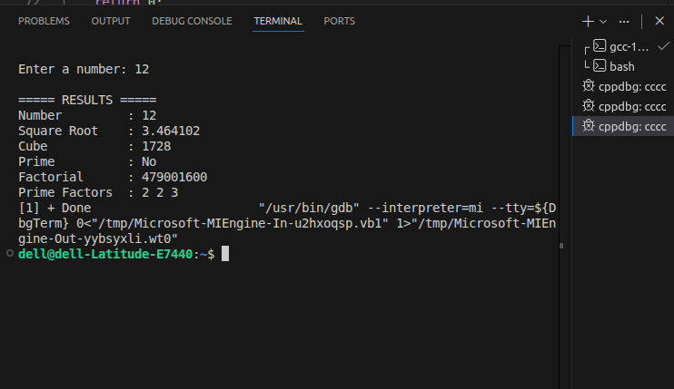
ASSIGNMENT 12
Problem Statement:
Write a C program to accept two numbers from the user and compute the smallest and greatest common divisor.

Input / Output:
Input:
Enter two numbers: 12 18

Output:
GCD (Greatest Common Divisor): 6
LCM (Smallest Common Multiple): 36

Program:
#include <stdio.h>

int gcd(int a, int b) { return b == 0 ? a : gcd(b, a % b); }

int main() {
int a, b;
printf("Enter two numbers: ");
scanf("%d %d", &a, &b);
int g = gcd(a, b);
printf("GCD: %d\n", g);
printf("LCM: %d\n", (a * b) / g);
return 0;
}
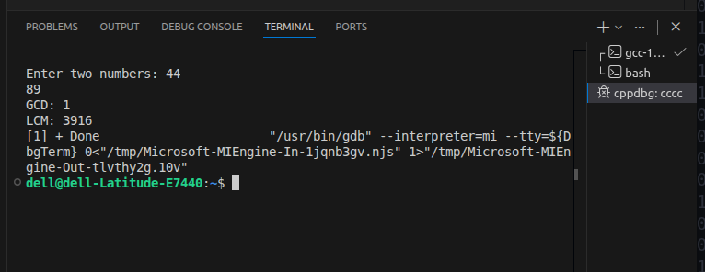
ASSIGNMENT 13
Problem Statement:
Write a C program to accept a number and print its digits in reverse order.

Input / Output:
Input:
Enter a number: 12345

Output:
Reversed: 54321

Program:
#include <stdio.h>

int main() {
int n;
printf("Enter a number: ");
scanf("%d", &n);
printf("Reversed: ");
while(n != 0) {
printf("%d", n % 10);
n /= 10;
}
printf("\n");
return 0;
}
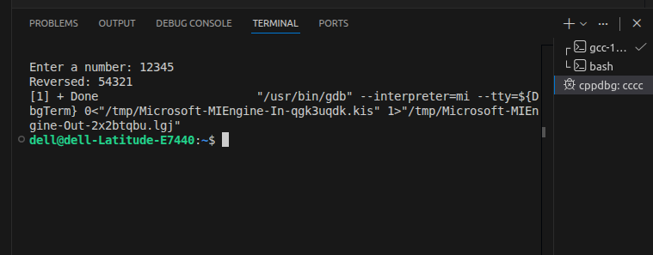
ASSIGNMENT 14
Problem Statement:
Write a C program to accept a binary number and convert it to a decimal number.

Input / Output:
Input:
Enter a binary number: 1010

Output:
Decimal equivalent: 10

Program:
#include <stdio.h>
#include <math.h>

int main() {
long bin;
int dec = 0, i = 0, rem;
printf("Enter binary number: ");
scanf("%ld", &bin);
long temp = bin;
while(temp != 0) {
rem = temp % 10;
dec += rem * pow(2, i);
temp /= 10;
i++;
}
printf("Decimal: %d\n", dec);
return 0;
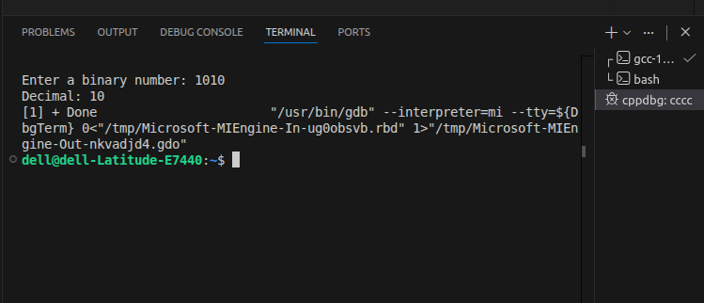
}

ASSIGNMENT 15
Problem Statement:
Write a C program to generate pseudo-random numbers.

Input / Output:
Input:
How many random numbers? 5

Output:
Random numbers: 1804289383 846930886 1681692777 1714636915 1957747793

Program:
#include <stdio.h>
#include <stdlib.h>
#include <time.h>

int main() {
int n;
printf("How many random numbers? ");
scanf("%d", &n);
srand(time(0));
printf("Random numbers:\n");
for(int i = 0; i < n; i++)
printf("%d\n", rand());
return 0;
}
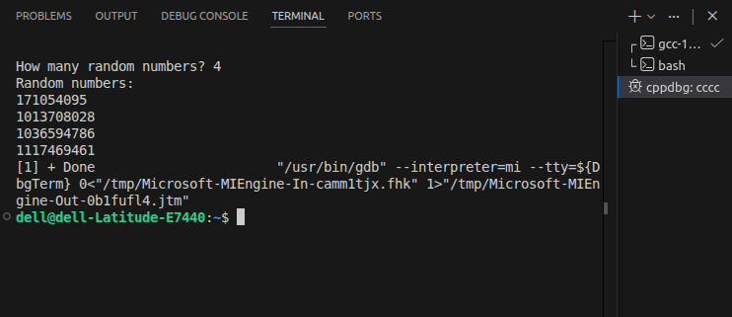
ASSIGNMENT 16
Problem Statement:
Write a C program to accept a list of n integers and partition the list into two sublists.

Input / Output:
Input:
Enter n: 6
Enter elements: 3 -1 7 -4 2 -9

Output:
Positive: 3 7 2
Negative: -1 -4 -9

Program:
#include <stdio.h>

int main() {
int n;
printf("Enter n: "); scanf("%d", &n);
int a[n], pos[n], neg[n], pc=0, nc=0;
printf("Enter elements: ");
for(int i=0;i<n;i++) scanf("%d",&a[i]);
for(int i=0;i<n;i++)
if(a[i]>=0) pos[pc++]=a[i]; else neg[nc++]=a[i];
printf("Positive: ");
for(int i=0;i<pc;i++) printf("%d ",pos[i]);
printf("\nNegative: ");
for(int i=0;i<nc;i++) printf("%d ",neg[i]);
printf("\n");
return 0;
}
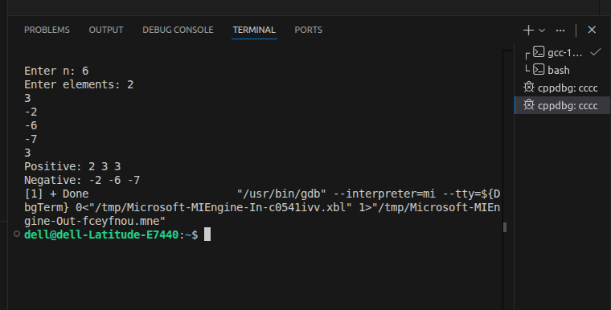
ASSIGNMENT 17
Problem Statement:
Write a C program to accept a number of terms and find the sum of sines of those terms.

Input / Output:
Input:
Enter number of terms: 3
Enter angles (degrees): 30 60 90

Output:
Sum of sines = 2.366

Program:
#include <stdio.h>
#include <math.h>

#define PI 3.14159265

int main() {
int n;
double sum = 0, angle;
printf("Enter number of terms: "); scanf("%d", &n);
printf("Enter angles in degrees:\n");
for(int i = 0; i < n; i++) {
scanf("%lf", &angle);
sum += sin(angle * PI / 180.0);
}
printf("Sum of sines = %.4f\n", sum);
return 0;
}
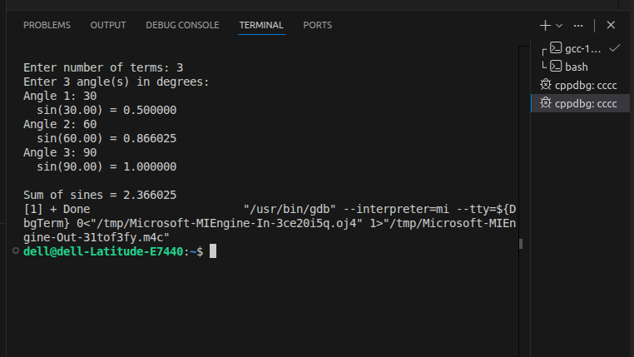
ASSIGNMENT 18
Problem Statement:
Write a C program to accept a string and perform various operations: length, reversal, equality check, palindrome, and substring.

Input / Output:
Input:
Enter string: madam

Output:
Length: 5
Reversed: madam
Palindrome: Yes
Substring 'ada' found at index 1

Program:
#include <stdio.h>
#include <string.h>

int main() {
char s[100], rev[100], sub[50];
printf("Enter string: "); scanf("%s", s);
int len = strlen(s);
printf("Length: %d\n", len);
for(int i=0;i<len;i++) rev[i]=s[len-1-i];
rev[len]='\0';
printf("Reversed: %s\n", rev);
printf("Palindrome: %s\n", strcmp(s,rev)==0?"Yes":"No");
printf("Enter substring to search: "); scanf("%s", sub);
char *p = strstr(s, sub);
if(p) printf("Found at index %d\n", (int)(p-s));
else printf("Not found\n");
return 0;
}
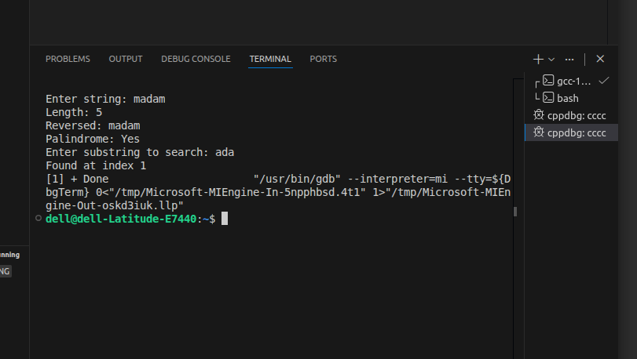
ASSIGNMENT 19
Problem Statement:
Define a structure for employee details (name, designation, gender, date of joining, salary) and compute total employees, count of male/female, employees with salary above 10,000, and employees with designation 'assistant manager'.

Input / Output:
Input:
Enter number of employees: 3
Enter details: Name, Designation, Gender (M/F), DOJ, Salary

Output:
Total employees: 3
Male: 2 Female: 1
Salary > 10000: 2
Assistant Managers: 1

Program:
#include <stdio.h>
#include <string.h>

struct Employee {
char name[50], desig[50], gender[10], doj[15];
float salary;
} emp[50];

void toLower(char *s, char *r) {
int i;
for (i = 0; s[i]; i++)
r[i] = (s[i] >= 'A' && s[i] <= 'Z') ? s[i] + 32 : s[i];
r[i] = '\0';
}

void readLine(char *buf, int size) {
fgets(buf, size, stdin);
buf[strcspn(buf, "\n")] = '\0';
}

int main() {
int n, i, male = 0, female = 0, highSal = 0, am = 0;
char tmp[50];

printf("Enter number of employees: ");
scanf("%d", &n);
getchar();

for (i = 0; i < n; i++) {
printf("\nEmployee %d:\n", i + 1);
printf("Name : "); readLine(emp[i].name, 50);
printf("Designation : "); readLine(emp[i].desig, 50);
printf("Gender : "); readLine(emp[i].gender,10);
printf("DOJ : "); readLine(emp[i].doj, 15);
printf("Salary : "); scanf("%f", &emp[i].salary);
getchar();
}

for (i = 0; i < n; i++) {
toLower(emp[i].gender, tmp);
if (strcmp(tmp, "male") == 0 || strcmp(tmp, "m") == 0) male++;
if (strcmp(tmp, "female") == 0 || strcmp(tmp, "f") == 0) female++;
if (emp[i].salary > 10000) highSal++;
toLower(emp[i].desig, tmp);
if (strcmp(tmp, "assistant manager") == 0 ||
strcmp(tmp, "assistant_manager") == 0) am++;
}

printf("\n========== RESULTS ==========\n");
printf("Total Employees : %d\n", n);
printf("Male : %d\n", male);
printf("Female : %d\n", female);
printf("Salary above 10,000 : %d\n", highSal);
printf("Assistant Managers : %d\n", am);

printf("\n--- Salary > 10,000 ---\n");
for (i = 0; i < n; i++)
if (emp[i].salary > 10000)
printf(" %s (%.2f)\n", emp[i].name, emp[i].salary);

printf("\n--- Assistant Managers ---\n");
for (i = 0; i < n; i++) {
toLower(emp[i].desig, tmp);
if (strcmp(tmp, "assistant manager") == 0 ||
strcmp(tmp, "assistant_manager") == 0)
printf(" %s\n", emp[i].name);
}

return 0;
}

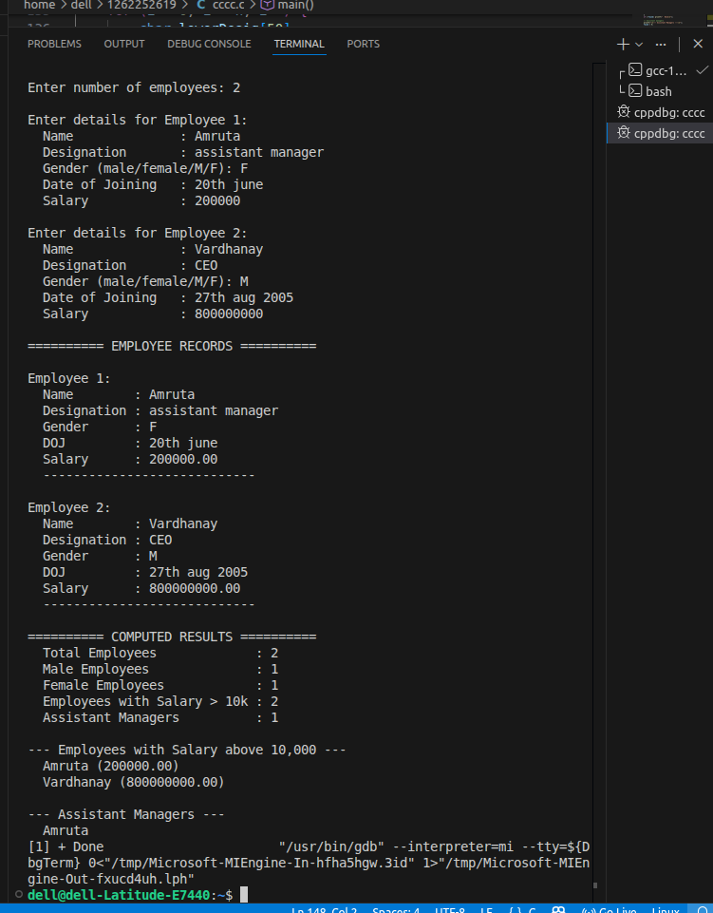
ASSIGNMENT 20
Problem Statement:
Write a C function to swap two numbers with and without pointers.

Input / Output:
Input:
Enter two numbers: 5 10

Output:
After swap (without pointers): a=10, b=5
After swap (with pointers): a=5, b=10

Program:
#include <stdio.h>

void swapWithout(int a, int b) {
int t = a; a = b; b = t;
printf("Without ptr: a=%d b=%d\n", a, b);
}

void swapWith(int *a, int *b) {
int t = *a; *a = *b; *b = t;
}

int main() {
int a, b;
printf("Enter two numbers: "); scanf("%d %d", &a, &b);
swapWithout(a, b);
swapWith(&a, &b);
printf("With ptr: a=%d b=%d\n", a, b);
return 0;
}
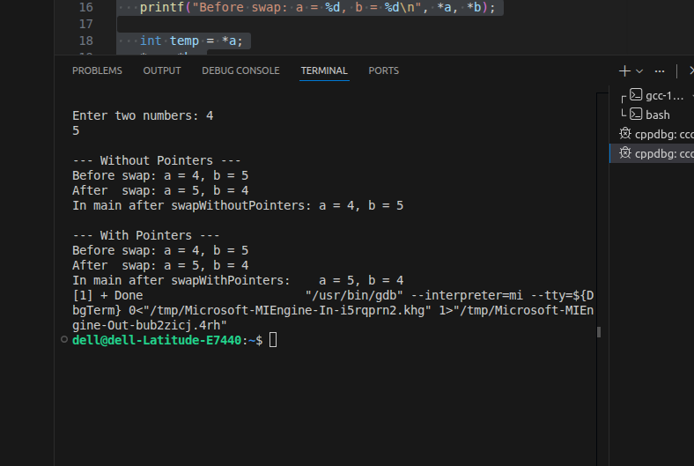
ASSIGNMENT 21
Problem Statement:
Write a C program to copy contents of one file to another using file handling.

Input / Output:
Input:
Enter source filename: source.txt
Enter destination filename: dest.txt

Output:
File copied successfully.

Program:
#include <stdio.h>

int main() {
FILE *src, *dst;
char srcFile[50], dstFile[50], ch;
printf("Source file: "); scanf("%s", srcFile);
printf("Dest file: "); scanf("%s", dstFile);
src = fopen(srcFile, "r");
if(!src) { printf("Cannot open source file.\n"); return 1; }
dst = fopen(dstFile, "w");
if(!dst) { printf("Cannot open dest file.\n"); return 1; }
while((ch = fgetc(src)) != EOF) fputc(ch, dst);
fclose(src); fclose(dst);
printf("File copied successfully.\n");
return 0;
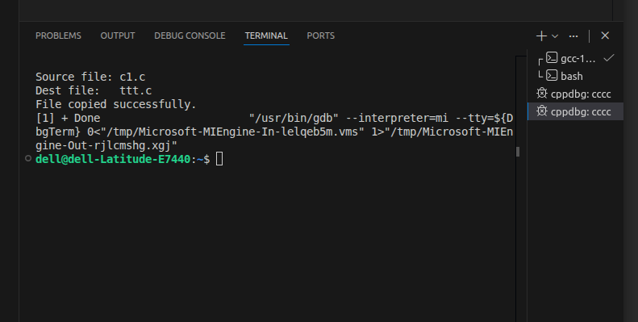
}

ASSIGNMENT 22
Problem Statement:
Write a menu-driven program in C to perform various string operations using in-built functions.

Input / Output:
Input:
Enter string: Hello
Choose operation (1-Length 2-Upper 3-Lower 4-Reverse 5-Concat): 2

Output:
HELLO

Program:
#include <stdio.h>
#include <string.h>
#include <ctype.h>

int main() {
char s[100], t[100];
int ch;
printf("Enter string: "); scanf("%s", s);
printf("1.Len 2.Upper 3.Lower 4.Reverse 5.Concat\nChoice: ");
scanf("%d", &ch);
switch(ch) {
case 1: printf("Length: %d\n", (int)strlen(s)); break;
case 2: for(int i=0;s[i];i++) s[i]=toupper(s[i]); printf("%s\n",s); break;
case 3: for(int i=0;s[i];i++) s[i]=tolower(s[i]); printf("%s\n",s); break;
case 4:
int l=strlen(s);
for(int i=0;i<l;i++) t[i]=s[l-1-i]; t[l]='\0';
printf("%s\n",t); break;
case 5:
printf("Enter second string: "); scanf("%s",t);
strcat(s,t); printf("%s\n",s); break;
}
return 0;
}

